**MarketHub**

*A Project Report Submitted*

to

**MANIPAL ACADEMY OF HIGHER EDUCATION**

*for Partial Fulfilment of the Requirement for the*

*Award of the Degree*

*Of*

**Bachelor of Technology**

*in*

**Computer and Communication Engineering**

*by*

**Shravani Sanjay Sawant, Aditi Rishiraj**

**230953006, 230953011**

*Under the guidance of*

Dr. Diana Olivia

Designation

Department of I&CT

Manipal Institute of Technology

Manipal, Karnataka, India



Dr. Diana Olivia

Designation

Department of I&CT

Manipal Institute of Technology

Manipal, Karnataka, India

**April 2025**

**ABSTRACT**

**Abstract**

**ACM taxonomy**

**SDG**

**Table of Contents**

**List of Tables**

**List of Figures**

**Abbreviations**

**Chapter 1 – Introduction**

**Chapter 2 – Literature Survey / Background**

**Chapter 3 – Objective / Problem Statement**

**Chapter 4 – Data Design**

**1.1 ER Design**

* + 1. 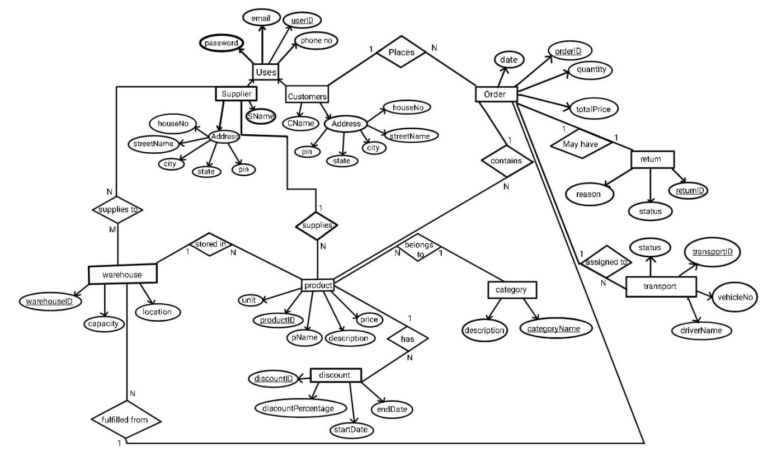
    2. Entities
       1. The User entity represents individuals registered in the system. It acts as the base entity for generalized roles such as Supplier and Customer. Each user has a unique identifier (userID) and authentication attributes like password.
       2. Supplier: The Supplier entity inherits attributes from User and stores additional details specific to suppliers, such as their name (sName), contact information, and address.
       3. Customer: Like Supplier, the Customer entity inherits attributes from User and includes customer-specific details such as their name (cName), contact information, and address.
       4. Product: The Product entity represents items available for purchase. Each product is uniquely identified by productID, and it has attributes such as pName, description, price, and unit.
       5. Category: The Category entity groups products under specific classifications (categoryName), with a description to provide additional context.
       6. Order: The Order entity represents purchase orders placed by customers. It includes attributes such as orderID, date, quantity, and totalPrice.
       7. Return: The Return entity represents instances where customers return products. It includes attributes such as returnID, reason, status, and the associated orderID.
       8. Transport: The Transport entity tracks delivery logistics, including vehicles and drivers assigned to orders. Attributes such as transportID, vehicleNo, driverName, and status ensure detailed shipment tracking.
       9. Warehouse: The Warehouse entity represents locations where products are stored. Attributes such as warehouseID, location, and capacity define the storage facilities.
       10. Discount: The Discount entity represents promotional offers on products. Attributes such as discountID, discountPercentage, startDate, and endDate link discounts to specific products.
  1. **Reduction**
     1. Mapping entities to relations

Each entity is converted into a relation with attributes and primary keys.

|  |  |  |
| --- | --- | --- |
| Entity | Attributes | Primary Key |
| User | userID, password | userID |
| Supplier | email, phoneNo, address(houseNo, streetName, city, state, pin), sName | Foreign key userID from User |
| Customer | email, phoneNo, address(houseNo, streetName, city, state, pin), cName | Foreign key userID from User |
| Product | productID, pName, description, price, unit | productID |
| Category | categoryName, description | categoryName |
| Order | orderID, date, quantity, totalPrice | orderID |
| Return | returnID, reason, status | returnID |
| Transport | transportID, vehicleNo, driverName, status | transportID |
| Warehouse | warehouseID, location, capacity | warehouseID |
| Discount | discountID, discountPercentage, startDate, endDate | discountID |

* + 1. Handling generalization

The ‘user’ entity is generalized into ‘supplier’ and ‘customer’

supplier and customer inherit userID from user

|  |  |  |
| --- | --- | --- |
| Entity | Attributes | Primary Key |
| User | userID, password | userID |
| Supplier | email, phoneNo, address(houseNo, streetName, city, state, pin), sName, userID | Foreign key userID from User |
| Customer | email, phoneNo, address(houseNo, streetName, city, state, pin), cName, userID | Foreign key userID from User |

* + 1. Converting relationships

The following relationships are present in the ER diagram

|  |  |  |
| --- | --- | --- |
| Relationship | Type | Implementation |
| Customer-order | One to many | Customer places order |
| Order-product | Many to many | Order contains product |
| Order-return | One to one | Order may have return |
| Order-transport | One to many | Order assigned to transport |
| Product-category | Many to one | Product belongs to category |
| Supplier-product | One to many | Supplier supplies product |
| Product-discount | One to many | Product has discount |
| Supplier-warehouse | Many to many | Supplier supplies to warehouse |
| Warehouse-product | One to many | Product stored in warehouse |
| Warehouse-order | Many to one | Order fulfilled from warehouse |

One to many: foreign keys are used to maintain references

Many to many: join tables are created

Updated list of tables:

|  |  |  |
| --- | --- | --- |
| Entity | Attributes | Primary Key |
| User | userID, password | userID |
| Supplier | email, phoneNo, address(houseNo, streetName, city, state, pin), sName, userID(references user) | Foreign key userID from User |
| Customer | email, phoneNo, address(houseNo, streetName, city, state, pin), cName, userID(references user) | Foreign key userID from User |
| Product | productID, pName, description, price, unit, categoryName(references category), userID(references supplier), warehouseID(references warehouse), orderID(references order) | productID |
| Category | categoryName, description | categoryName |
| Order | orderID, date, quantity, totalPrice, userID(references customer) | orderID |
| Return | returnID, reason, status, orderID(references order) | returnID |
| Transport | transportID, vehicleNo, driverName, status, orderID(references order) | transportID |
| Warehouse | warehouseID, location, capacity, orderID(references order) | warehouseID |
| Discount | discountID, discountPercentage, startDate, endDate, productID(references product) | discountID |
| Supplies | userID(references supplier), warehouseID(references warehouse) | userID, warehouseID |

* + 1. Handling Composite and Multivalued Attributes

Address is a composite attribute.

The address attribute was decomposed into atomic fields (houseNo, city, etc.) to enable location-based analytics and comply with 1NF.

|  |  |  |
| --- | --- | --- |
| Entity | Attributes | Primary Key |
| User | userID, password | userID |
| Supplier | userID, sName, email, phoneNo | userID |
| Customer | userID, cName, email, phoneNo | userID |
| Address | userID, houseNo, streetName, city, state, pin | UserID |

* 1. **Normalization**
     1. First Normal Form (1NF)

Ensure atomic values (no multivalued attributes or repeating groups)

If warehouseID and orderID is stored in the product table (according to reduction rules) it will need to unnecessary repeating of details. Similar problem occurs with orderID being stored in warehouse table To avoid it, following changes can be made:

|  |  |  |
| --- | --- | --- |
| Entity | Attributes | Primary Key |
| Product | productID, pName, description, price, unit, categoryName(references category), userID(references supplier) | productID |
| Order | orderID, date, quantity, totalPrice, userID(references customer) | orderID |
| Warehouse | warehouseID, location, capacity | warehouseID |
| Contains | orderID(references order), productID(references product), productQuantity | orderID, productID |
| Storage | warehouseID(references warehouse), productID(references product), productQuantity | warehouseID, productID |
| Fulfill | warehouseID(references warehouse), orderID(references order), productID(references contains) | warehouseID, orderID, productID |

* + 1. Second Normal Form (2NF)

Remove partial dependencies. Partial dependencies were eliminated by ensuring all non-key attributes depend entirely on primary keys.

* + 1. Third Normal Form (3NF)

Remove transitive dependencies. Transitive dependencies were eliminated by ensuring all non-key attributes depend entirely on primary keys.

* 1. **Relational Schema**

These are the final relations

**User table**

|  |  |  |
| --- | --- | --- |
| Attribute | Data type | Constraints |
| UserID | VARCHAR (10) | Primary key |
| Password | VARCHAR (20) | NOT NULL |

**Supplier table**

|  |  |  |
| --- | --- | --- |
| Attribute | Data type | Constraints |
| UserID | VARCHAR (10) | Primary key, Foreign key references **User** |
| sName | VARCHAR(20) | NOT NULL |
| Email | VARCHAR(50) | NOT NULL |
| Password | VARCHAR (20) | NOT NULL |
| PhoneNo | INT | NOT NULL |

**Customer table**

|  |  |  |
| --- | --- | --- |
| Attribute | Data type | Constraints |
| UserID | VARCHAR (10) | Primary key, Foreign key references **User** |
| cName | VARCHAR(20) | NOT NULL |
| Email | VARCHAR(50) | NOT NULL |
| Password | VARCHAR (20) | NOT NULL |
| PhoneNo | INT | NOT NULL |

**Address table**

|  |  |  |
| --- | --- | --- |
| Attribute | Data type | Constraints |
| UserID | VARCHAR (10) | Primary key, Foreign key references **User** |
| houseNo | VARCHAR (10) | NOT NULL |
| streetName | VARCHAR (50) | NOT NULL |
| City | VARCHAR (50) | NOT NULL |
| State | VARCHAR (50) | NOT NULL |
| PIN | INT | NOT NULL |

**Product table**

|  |  |  |
| --- | --- | --- |
| Attribute | Data type | Constraints |
| productID | VARCHAR (10) | Primary key |
| pName | VARCHAR(50) | NOT NULL |
| Description | VARCHAR (100) | NOT NULL |
| Price | INT | NOT NULL |
| Unit | VARCHAR(10) | NOT NULL |
| categoryName | VARCHAR (50) | Foreign key references **category** |
| userID | VARCHAR (10) | Foreign key references **Supplier** |

**Order table**

|  |  |  |
| --- | --- | --- |
| Attribute | Data type | Constraints |
| orderID | VARCHAR (10) | Primary key |
| Date | DATE | NOT NULL |
| Quantity | INT | NOT NULL |
| totalPrice | INT | NOT NULL |
| userID | INT | Foreign key references **customer** |

**Warehouse table**

|  |  |  |
| --- | --- | --- |
| Attribute | Data type | Constraints |
| warehouseID | VARCHAR (10) | Primary key |
| Location | VARCHAR(50) | NOT NULL |
| Capacity | INT | NOT NULL |

**Category table**

|  |  |  |
| --- | --- | --- |
| Attribute | Data type | Constraints |
| categoryName | VARCHAR (30) | Primary key |
| Description | VARCHAR(50) | NOT NULL |

**Return table**

|  |  |  |
| --- | --- | --- |
| Attribute | Data type | Constraints |
| returnID | VARCHAR (10) | Primary key |
| Reason | VARCHAR (100) | NOT NULL |
| Status | VARCHAR (10) | NOT NULL |
| orderID | VARCHAR (10) | Foreign key references **order** |

**Transport table**

|  |  |  |
| --- | --- | --- |
| Attribute | Data type | Constraints |
| transportID | VARCHAR (10) | Primary key |
| vehicleNo | VARCHAR(10) | NOT NULL |
| driverName | VARCHAR (20) | NOT NULL |
| Status | VARCHAR (10) | NOT NULL |

**Shipment table**

|  |  |  |
| --- | --- | --- |
| Attribute | Data type | Constraints |
| transportID | VARCHAR (10) | Primary key |
| orderID | VARCHAR(10) | Primary key |

**Discount table**

|  |  |  |
| --- | --- | --- |
| Attribute | Data type | Constraints |
| discountID | VARCHAR (10) | Primary key |
| discountPercentage | INT | NOT NULL |
| startDate | DATE | NOT NULL |
| endDate | DATE | NOT NULL |
| productID | VARCHAR (10) | Foreign key references **product** |

**Supplies table**

|  |  |  |
| --- | --- | --- |
| Attribute | Data type | Constraints |
| userID | VARCHAR (10) | Primary key |
| warehouseID | VARCHAR (10) | Primary key |

**Contains table**

|  |  |  |
| --- | --- | --- |
| Attribute | Data type | Constraints |
| orderID | VARCHAR (10) | Primary key |
| productID | VARCHAR (10) | Primary key |
| Quantity | INT | NOT NULL |

**Storage table**

|  |  |  |
| --- | --- | --- |
| Attribute | Data type | Constraints |
| warehouseID | VARCHAR (10) | Primary key |
| productID | VARCHAR (10) | Primary key |
| productQuantity | INT | NOT NULL |

**Fulfill table**

|  |  |  |
| --- | --- | --- |
| Attribute | Data type | Constraints |
| orderID | VARCHAR (10) | Primary key |
| productID | VARCHAR (10) | Primary key |
| warehouseID | VARCHAR (10) | Primary key |

**Chapter 5 – Methodology**

**Implementation details with block diagram to explain the project in detail**

**Chapter 6 – Results**

**Chapter 7 – Conclusion and Future Work**

**Chapter 8 – References**

**In IEEE format**